Dear Affiliates,

Standing here in front of you today is a solid proof that the world is changing.

IFATSEA Women Committee is a new initiative and we thank the executive board
for supporting this group. This means that IFATSEA is finally stepping into a new era
and a new reality.

In the past decades, women around the globe started to access education and job
opportunities that seemed impossible for them, breaking cultural and social
stereotypes. This process still continues and all of us need to support this thing.

This year's United Nation’s report regarding the involvement of women in STEM
(Science, Technology, Engineering and Mathematics) highlighted that a significant
gender gap persisted throughout the years. Some concerning informations are
presented in the UN report as:

- Today, only one in three science and engineering researchers in the world is a
woman.
- Women are less present in company leadership and in technical roles and do not
have equal opportunities in the workplace.
- But the most concerning issue is that only 28% of the engineering graduates are
women.

We can't discuss about supporting and increasing the number of ATSEP women
without taking into account the educational process. We need to fully support also
the equal access and participation for women and girls in technology and
engineering studies. Women represent half of the world's population, which means
half of its potential.

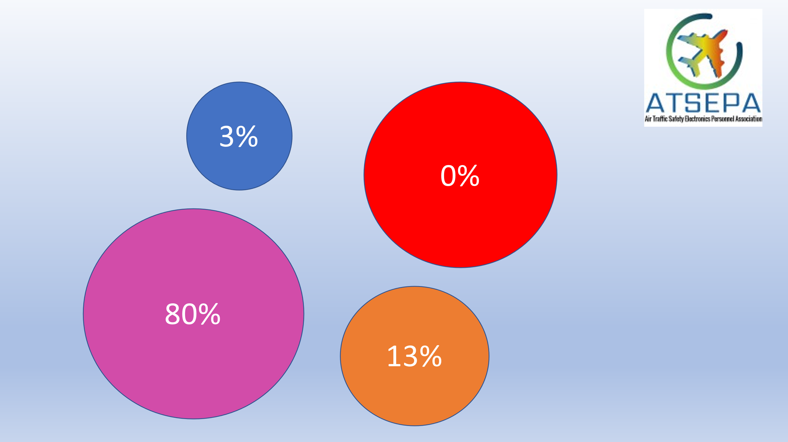
Therefore, ATSEPA Romania has initiated a survey that aims to discover the
strengths and challenges of IFATSEA Women. Preliminary data gathered from our
ATSEP women in Europe it highlighted some major issues:
- Only 3% of ATSEP women are under 30 years old
- 0% of women have a management position
- 13% of women have less than 5 years professional experience as ATSEP
- 80% of women describe the initial stage of the ATSEP career in terms of the access
to the job as difficult (from moderate 43% to extremely difficult 10%)

For this matter, it is mandatory and also normality for IFATSEA to promote and
support equal opportunities for women to access and develop professional careers
in aviation.

The newly formed but motivated Women Committee has the determination and
tenacity to transform the European initiative in a global one.

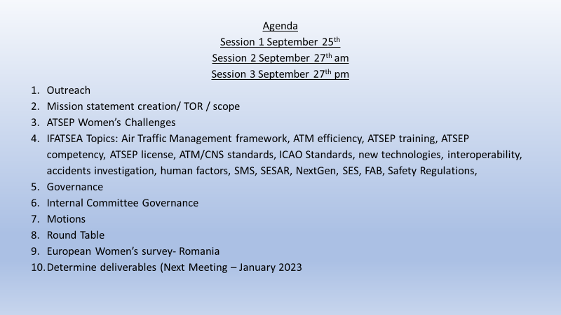
As a committee we met several times this week to complete our work. We were very successful in completing our Terms of reference and have a solid understanding of the work we would like to do.
Our first order of business was to solidify our composition so we elected our co-chairs and secretary. Camelia and I will co-chair this committee for a 2 year term and Orefile Mthombeni will serve the same length term as secretary.

From the data we have already collected and our discussions we were able to formulate 5 main goals for this committee. They are:

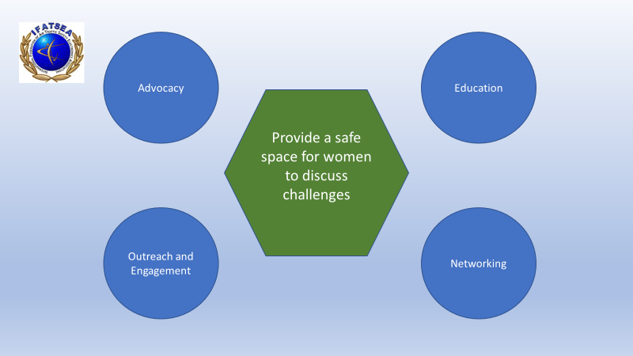
1. Outreach and Engagement- To Communicate with Women ATSEPs worldwide. To encourage participation in this committee and share experiences and challenges, and to encourage the recruitment and retention of women into ATSEP roles.
2. Advocacy- We will lobby government organizations, and communicate with Private ANSPs and Educational Institutions on topics raised in the committee
3. Education- We will Increase visibility of ATSEP women’s work outside our organization and educate our own members on the challenges we face.
4. Networking- Take advantage of opportunities to increase our connections as we do our work.
5. Most importantly we wish to provide a safe space for Women ATSEPs to meet and share current challenges. As we continue our work we would like to invite our supporters and allies to join us for an open session at each general assembly as observers.

We determined that our first exercise must be to gather a complete picture of the reality of women ATSEPs across the globe. Therefore, our deliverables will be firstly to expand the European survey to each of our affiliate countries and ensure that we have a whole picture view of women in all IFATSEAs regions and we will accomplish this by communicating directly with the affiliate countries in each of our regions.

The women’s cte put a lot of thought into how we can continue to increase our involvement in this organization. And I am very pleased to be able to announce to you all that the committee now has advisory seats on all 3 subcommittees moving forward. We sincerely thank the exec for considering our request and granting it in part.
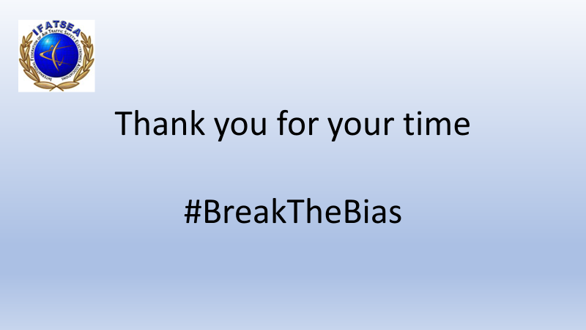
Thank you for your time and attention. Together we can #Breakthebias for future generations!

